ESRW Red Wave Article
April, May, June 2021

On April 28, we held our first quarterly night meeting and new member social at The Fairhope Yacht Club. We had a huge turnout with over 55 business and professional women and men. Our membership committee designed a membership template with square payment capability that allowed us to email and text prospective members and associates. Our guest speaker, AFRW President Britney Garner, spoke to the crowd about issues affecting us on a local, state, and national level. Our next quarterly night meeting will be July 28 in the Fairhope Yacht Club Ballroom with RSVP’s required.

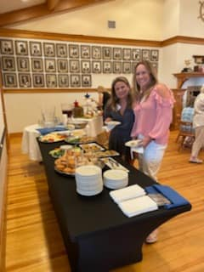

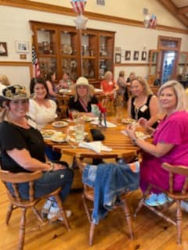

Five ESRW Board Members attended AFRW Legislative Days in Montgomery in April. We learned a lot about current legislative issues, met up with old friends and forged new friendships with like-minded women across the state. We enjoyed touring the Governor’s Mansion, meeting legislators and won 3rd place for our table at Grazing with the Elephants at the Montgomery Zoo!

Our guest speaker for April was Congressman Jerry Carl who encouraged us to not give up with “We’ve Still Got a Voice.” He gave us updates on legislation he is working on and what is happening in DC now. We passed two resolutions in April with the first one commending Representative Matt Simpson for establishing through law the Baldwin County Mental Health Court. The second resolution designating Ann Bedsole for 2021 March Women’s History Month. Said resolution acknowledges the marked and distinguished historic achievements native born Alabamian, Ann Bedsole.

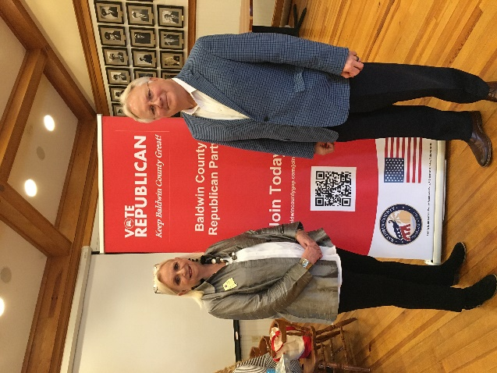

Our May speaker was John Wahl, Chairman of Alabama Republican Party. He previously served as Senior Vice Chair for ALGOP. He was part of the transition team for Senator Tommy Tuberville. His goal as chair is to make the Republican Party more effective and more successful. He is particularly interested in fighting for election security and preparing for the upcoming elections.

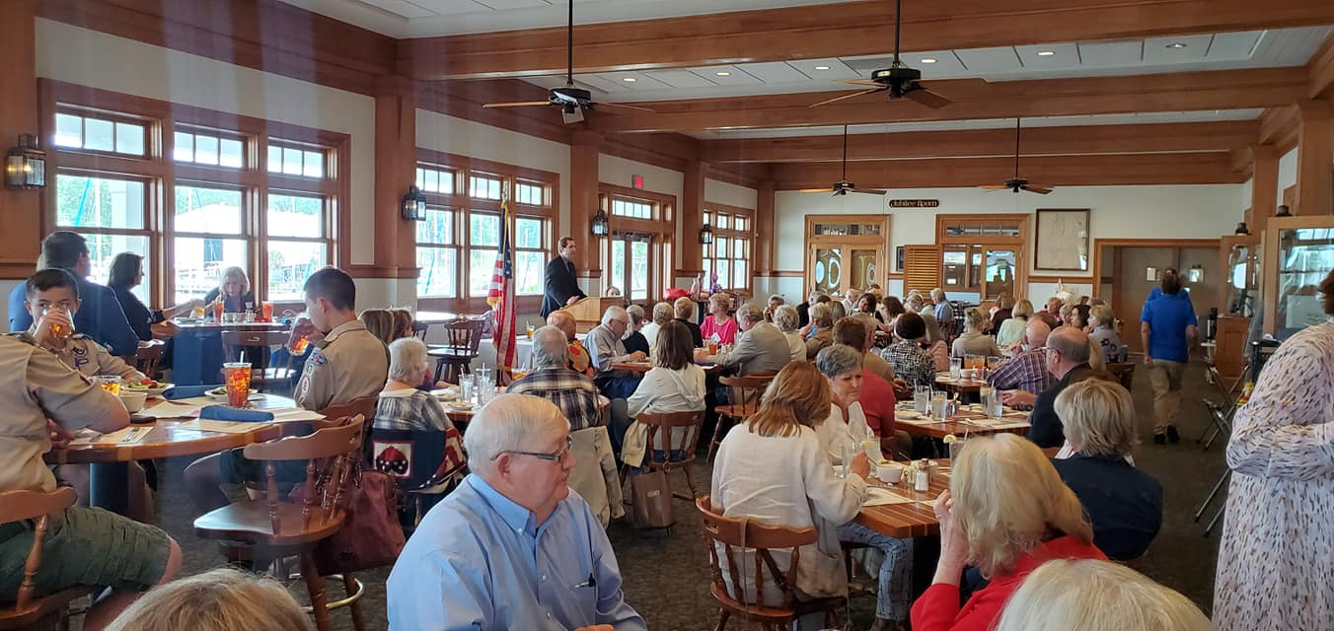

In June speaker Congressman Mo Brooks, 5th District, spoke to a packed house of 112 people. Congressman Brooks spoke on a variety of topics centered on the antics and efforts of Socialist Democrats in Washington and around the country and ways in which we, as Conservatives, can combat their misinformation and misdirection.

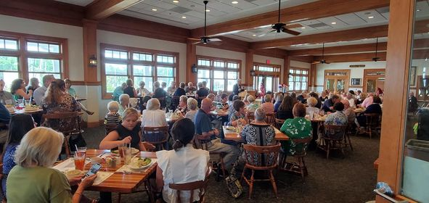

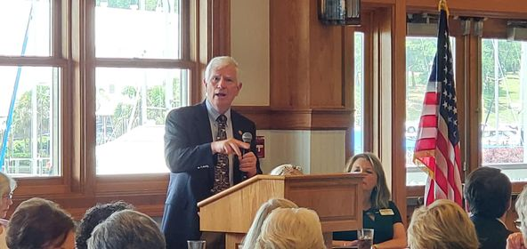

We presented two resolutions in June, with the first one being rejection of the Critical Race Theory. The second resolution was on Election Integrity and to reject United States House Resolution 1 and United States Senate 1 (HR1/S1).

One of the exciting firsts for our club in May/June was the launch of esrw.org where current and prospective members can find the latest information on our club, upcoming speakers and more. We also developed and sent our first online membership directory to current members.

We filled out our NFRW Achievement Awards Packet and turned it in June 1. We are excited to announce that we reached 150 members which makes us a mega club for the first time in our club’s history!

